Directions: The goal of the following problems is to help challenge and deepen your understanding of the current topic. Don’t assume that you will know how to answer every question. You will work with at least two other students in the class to try and find solutions and write arguments for each of the following questions. Be sure that you question your classmates’ reasoning. If you don’t understand how they are getting something, you should ASK THEM TO EXPLAIN! Being able to defend your reasoning is important and so you are actually helping them by asking them to explain.

Challenge Questions

- Consider the region in the polar plane which exists inside (and on) a unit circle centered at the origin.
- Describe the coordinates of all polar points that are in this region

- Find the area inside this curve and in the 4th quadrant using geometry.

- Find the area inside this curve and in the 4th quadrant using polar integration.

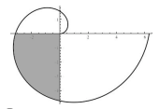
- Find the area of the shaded region of .

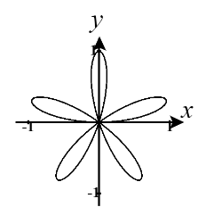
- Consider the curve .
- Find the area of the region enclosed by one loop of the curve.

- Set up an integral for the total length of the curve.

- The diagram below shows the curve where a is a positive constant. Determine the value of a given that the area bounded by the curve is .
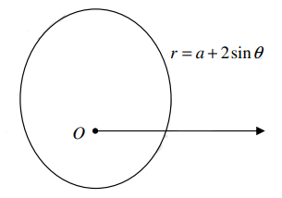

- Consider the region which exists within both the curve and .
- Determine the area of this region.

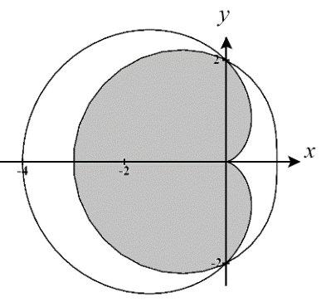

- Setup, but do not evaluate, an integral(s) which represents the arc length of the boundary of this region.

- Determine the area that is within but outside of .

- Determine the area that is within but outside of .

- A point P lies on the polar curve , so that the tangent line to the curve at P is parallel to the x-axis.
- Determine the exact length of the line segment that connects P to the origin.

- Find the polar and Cartesian coordinates of the point P.

